Motion and Force in a Gravitational Field

Test 2: Circular Motion, Universal Gravitation, Torque and Equilibrium

Name: ___________________________________________________ (32 marks)
Maximum 2 marks deducted for incorrect units and significant figures.

Time allowed: 1 hour

Outcomes covered in this test:
- explain and apply the concepts of centripetal acceleration and centripetal force, as applied to uniform circular motion—this will include applying the relationships: $a_{c}=\frac{v^{2}}{r},\text{ resultant F}=\text{ma}=\frac{{\text{mv}}^{2}}{r}$
- describe and interpret the radial gravitational field distribution around a single (point) mass
- explain and apply Newton's Law of Universal Gravitation and the concept of gravitational acceleration, g, as gravitational field strength—this will include applying the relationships: $F_{g}=G\frac{m_{1}m_{2}}{r^{2}}\text{, g}=G\frac{M}{r^{2}}$
- explain the conditions for a satellite to remain in a stable circular orbit in a gravitational field, and calculate the parameters of satellites in stable circular orbits—this will include applying the relationships:
$v_{\text{av}}=\frac{s}{t}\text{, }a_{c}=\frac{v^{2}}{r},\text{ resultant F}=\text{ma}=\frac{{\text{mv}}^{2}}{r},$$F_{g}=G\frac{m_{1}m_{2}}{r^{2}}\text{, g}=G\frac{M}{r^{2}}$.
- describe and explain the impact of satellites and associated technologies on everyday life
- explain and apply the concept of torque or moment of a force about a point, and the principle of moments, and their application to situations where the applied force is perpendicular to the lever arm - this will include applying the relationships: $τ=\text{rF}\text{ and }Στ=0$ .
- explain and apply the concept of centre of mass
- explain and apply the concept of a rigid body in equilibrium—this will include applying the relationships: $ΣF=0, τ=\text{rF}\text{ and }Στ=0$
Assume no air resistance.

- Imagine that two new planets have been discovered in another solar system, call them X and Y. They both have the same radius but planet X has twice the mass of planet Y. On the diagram below, draw in the gravitational fields for each planet. (2 marks)

X Y

- 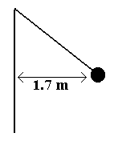A hammer thrower has gradually increased the speed of his hammer so that it completes ten revolution in 22.0 s. The hammer of mass 7.26 kg may be considered to be moving in a horizontal circle of 1.70 m radius. What force is exerted on the hammer thrower’s arm? (4 marks)

- Discuss one important use for satellites that are evident in our daily lives. (2 marks)
__________________________________________________________________________________________________________________________________________________________________________________________________________________________________________________________________________________________________________________________________________________________________________________________________________________________________________________________________________________________________________________________________________________________________________________________________________________________________________________________________________________________________________________________________________________________________________________________________
- Ben. whose total mass is 1.20 x 10² kg (Ben and space suit) is on a space walk 725 km above the Earth. Assuming that the force of the nearby space ship is insignificant compared to the force of the Earth,
- What gravitational acceleration does Ben experience on his space walk? (2 marks)

- What gravitational force is on Ben? (2 marks)

- The mass of Jupiter is 1.90 x 10²⁷ kg and its diameter is 142 984 km. What altitude would a satellite have if its orbital speed is 3.00 x 10⁴ ms⁻¹? (3 marks)


- Look at the diagrams of the wine glass and coffee mug. Mark in the centre of mass on each and then explain which is more stable and why? (3 marks)

__________________________________________________________________________________________________________________________________________________________________________________________________________________________________________________________________________________________________________________________________________________________________________________________________________________________________________________________________________________________________________________________________________________________________________________________________________________________________________________________________________________________________________________________________________________________________________________________________________________________________________________________________________________________________________________
- A shopkeeper wants to hang two signs from a 10.3 kg horizontal pole fixed to the wall. The first sign has a mass of 5.20 kg and is to be hung 0.800 m from the wall. The second sign has a mass of 6.60 kg and is to be hung 0.200 m from the end of the pole. The pole is 2.00 m in length. If the fixture at the wall can withstand a torque of 2.50 x 10² Nm, will the shopkeeper need to add additional support to the pole? (3 marks)

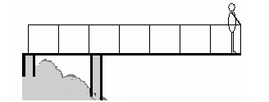
- Alan (85.0 kg) is standing 0.500 m from the end of a 4.60 m viewing platform which extends out over a scenic river. The 2.30 x 10³ kg platform is support by two supports, one at the start of the platform and one 1.60 m from the start as shown. Determine the force on each support. (4 marks)

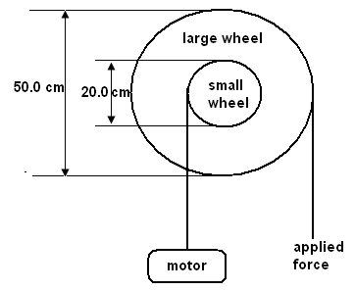
- A windlass is a simple machine that consists of two concentric wheels of different diameter than can be used to lift heavy weights. A home mechanic is using a windlass to lift a 225 kg engine out of his car. The smaller wheel of the windlass has a diameter of 20.0 cm and the larger wheel 50.0 cm. Calculate the minimum force necessary to lift the engine out of the car. (2 marks)

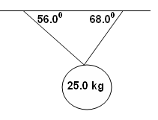
- A mirror ball hangs from the ceiling at a local nightclub. The two supporting wires have angles of 68.0⁰ and 56.0⁰ to the horizontal. The mirror ball has a mass of 25.0 kg. Calculate the tension in each wire. (5 marks)

